So Many Thanks!

Staff Contacts

Tammy Turple Ext 309
Executive Director

Tara Billard Ext 301
Office Administrator

Andrea Townsend Ext 302
Centre Coordinator

Stevie Fort Ext 314
Program Support

Taylor Gear Ext 306
Playroom Facilitator

Nicole Clarke Ext 313
Family Wellness

Sarah White Ext 303
Healthy Beginnings/Fund Development

Krista Greencorn Ext 304
Healthy Beginnings

Erin Fair Ext 305
Volunteer Doula Program

Whitney Cruikshank Ext 307
Volunteer Doula Program

Erinn Baillie Ext 307
Youth & Community Outreach

Jane Hall Ext 310
Family Home Daycare

Ginny Hennigar Ext 310
Family Day Home Consultant

Sabah Randell Ext 311
Parenting Journey Educator

Josie Webster Ext 315
Parenting Journey Educator

Sharelyn Stone Ext 312
Prenatal/Postnatal Educator

Thanks to the kindness of the Halifax Shoebox Project (and their supporters), J.L Ilsley basketball tournament and a group of Brownies we were able to support many families with toys and food over the holidays.
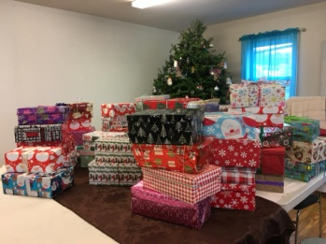
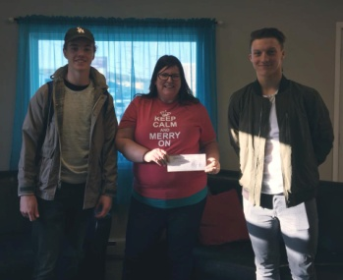
Also a huge thank you to the group from the Port of Halifax who volunteered during the United Way Day of Action to paint our play room!
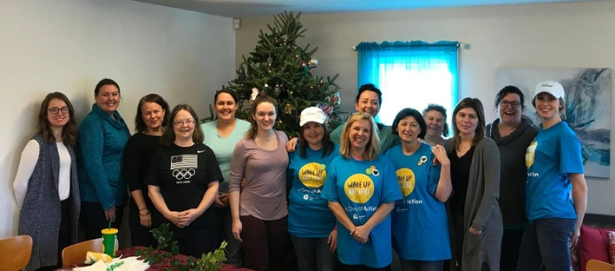

Heating Assistance Rebate
The Heating Assistance Rebate Program (HARP) helps with the cost of home heating for low-income Nova Scotians who pay for their own heat. Rebates range from $100 to $200. You can apply until March 31, 2018.

Eligibility:
To qualify for the rebate, you must pay for your own heat and meet 1 of the following criteria:
- - Have a net income of $29,000 or less and live alone with no kids or dependents
- - Have a combined net income of $44,000 or less and live with kids, dependents, or other adults
- - Receive income assistance from the Department of Community Services
- - Receive the Guaranteed Income Supplement or the Allowance from Service Canada

Storm Policy
It’s that time of year where we let everyone know our storm cancellation policy. If HRSB schools are closed, or school buses are not running due to inclement weather, we will also be closed.
If you are in doubt as to whether we are closed, please call ahead or check our social media pages.

Infant Massage
Infant massage can be a great way for caregivers to connect with their baby. It can help to communicate affection and security, while learning more about your baby and their cues.
Infant massage can also increase circulation, promote relaxation and reduce discomfort from constipation.
Join us on Thursdays at 1:15pm for this free drop in program. No registration is required. Please call ahead if you require childcare for an older child. We generally recommend this program for infants that are at least a month old, and generally not able to crawl.

Produce Packs
The success of the Mobile Food Market Produce Packs will be continuing in 2018. For just $10 you will receive a bag filled with staple fruit and vegetables.

Order and Pay | Pick up
January 17 | January 31
January 31 | February 14
February 14 | February 28
February 28 | March 14
March 14 | March 28
March 28 | April 1

