Volunteer Doula Program celebrates 20 years!
Staff Contacts
Tammy Turple
Executive Director
Ext 309

Deborah Hutchinson
Office Administrator
Ext 301

Andrea Townsend
Centre Coordinator
Ext 302

Taylor Gear
Program Support
Ext 314

Nicole Clarke
Family Wellness
Ext 313

Sarah Hicks
Home Visitor
Fund Development
Ext 303

Krista Greencorn
Home Visitor
Ext 304

Ginny Hennigar
Playroom Facilitator
Ext 306

Erin Fair
Volunteer Doula Program
Ext 305

Whitney Cruikshank
Volunteer Doula Program
Ext 307

Erinn Bailie
Youth & Community Outreach
Ext 307

Jane Hall
Family Home Daycare
Ext 310

Sabah Randell
Parenting Educator
Ext 311

Jessie Harrold
Prenatal/Postnatal
Ext 312

Andrea Townsend
Centre Coordinator
Ext 302

On July 6, 2016 at the IWK, we celebrated 20 years of the VDP with our friends and partners at the IWK Health Centre.
Program founder Hilary Marentette spoke about the humble beginnings, before being presented with CTV News at 5: Maritimer of the Week. Program Coordinator Erin Fair spoke about the ups and downs of the program, and two moms shared their birthing experience and the benefits of having a volunteer doula by their side.
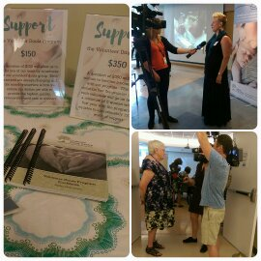
Thank you to everyone who has supported the Volunteer Doula Program, all of the doulas, and all of the families who allowed us to be a part of their birthing experience. We look forward to serving many more families!

What is a doula? A doula is someone who provides emotional support, physical comfort support and practical information to women and their families.
Why have a doula? Studies have found that births tend to be shorter and with fewer complications, reduces negative feelings about birthing experience, reduces the need for medical interventions, as well as reduces requests for epidurals and pain medications.
For more information on the Volunteer Doula Program: www.HomeOfTheGuardianAngel.ca/ volunteer-doula-program
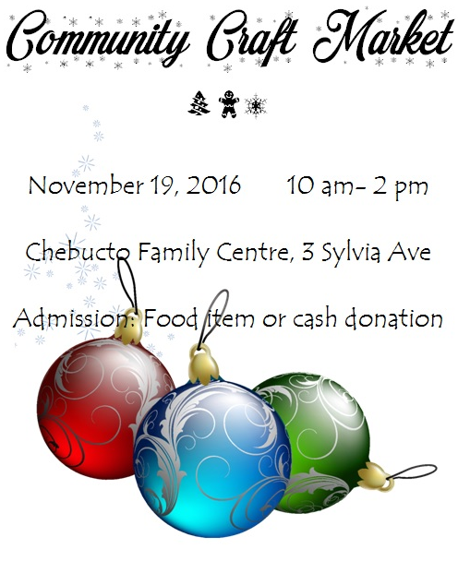

Good Food First Club
Getting experience in the kitchen and gaining knowledge about food was the aim for the Good Food First Club this summer.
The group of youth met for four weeks. Each week they explored different types of foods, tried new vegetables, and cooked.
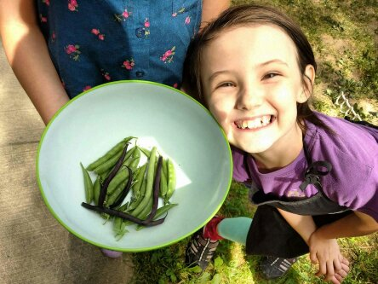
Toonies for Change

It all starts with a toonie! Chebucto Family Centre is pleased to be one of the recipients of Rotary Club of Halifax Northwest’s Toonies for Change.
Each week play your toonie at participating vendors for a chance to win 50% of the jackpot. The remaining money is divided between local charities and the Rotary Club.
With 20 supporting vendors, what are you waiting for? Play your toonie each week for the chance to win! www.tooniesforchange.com
Rae’s Awareness
On November 17, 2016, Leah Parson’s
of the Rehteah Parson’s Society will be joining
us for a conversation on the consequences of
sexual assault, “victim blaming” and bullying.
We hope you’ll join us. More details coming
soon!
Stay Connected
Chebucto Family Centre
ChebuctoFamilyCentre
@CFC_hfx

