Important Dates and Events
Staff Contacts

Tammy Turple
Executive Director
Ext 309

Deborah Hutchinson
Office Administrator
Ext 301

Andrea Townsend
Centre Coordinator
Ext 302

Taylor Gear
Program Support
Ext 314

Nicole Clarke
Family Wellness
Ext 313

Sarah Hicks
Home Visitor
Fund Development
Ext 303

Krista Greencorn
Home Visitor
Ext 304

Ginny Hennigar
Playroom Facilitator
Ext 306

Erin Fair
Volunteer Doula Program
Ext 305

Whitney Cruikshank
VDP Assistant
Ext 307

Erinn Bailie
VDP Assistant
Youth & Community Outreach
Ext 308

Jane Hall
Family Home Daycare
Ext 310

Josie Webster/Sabah Randell
Parenting Journey Educator
Ext 311

Jessie Harold
Prenatal/Post Natal Educator
Ext 312

April 1 & 9 – Red Cross Babysitting Course
April 23 – Community Craft Market
May 7 – Book Bonanza
May 13-15 – Birth Doula Training
May 26 – Comedy for Community Fundraiser

Mix 96-5 Presents: Comedy for Community

Comedy for Community is a night of laughter and cheer in support of Chebucto Family Centre.
Your night will begin relaxing in the lounge, glass of wine in hand, browsing the many items available at the silent auction tables. At 8pm we will transition into the theatre for the first act of the night with comedian Ian Black.
Following the intermission we will return to the theatre for more laughs, featuring Carey Lee and Francois Webber. Winner of silent auction items will be posted after the show.
Tickets are $25 and include two glasses of wine or beer, hors d'oeuvres and a great night with friends and family in support of Chebucto Family Centre.
Tickets available at Chebucto Family Centre or through the Bella Rose Arts Centre Box Office

Welcome back!
We are pleased to announce the return of Whitney Cruikshank and Jessie Harold. Whitney will be returning as the VDP assistant and Jessie will be our Prenatal/Post Natal educator. Krista Greencorn will also be moving from her role in program support to a home visitor with the Healthy Beginnings Program. Taylor Gear will now be in the program support role full time. We also welcome Sabah Randell to the Parenting Journey role!
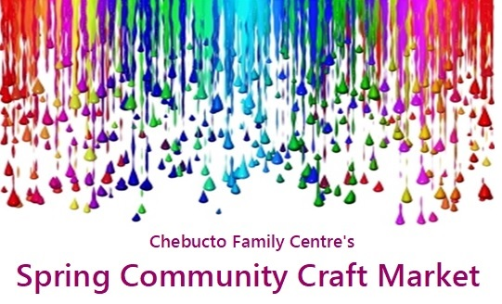
Community Craft Market
Our first one was so fun we’ve decided to do it again!
Join us April 23 from 10am until 2pm for a craft market. We’re pleased to have a number of returning vendors, and new crafters including reachAbility’s 100% Pop-Up Shop.
We will have everything from wood crafts to sea glass art to infinity scarves, handmade soaps and even more! Please bring a non-perishable food item for admission. CFC will be selling baked goods and popcorn again! Thanks, Dan Doherty for the use of popcorn maker.
Youth Programming
With Erinn starting in her new role as Youth and Community Outreach Coordinator we are excited to announce we have started offering more youth programming!
Over March Break the youth were in the kitchen making tacos, cookies and fruit smoothies and showing off their creative side at Clay Cafe.
Over two days in April Kim Mundle’s First Aid Training will be offering a free babysitting course for a group of youth. We can look forward to lots of new certified babysitters in the area!

Spryfield Book Bonanza
The Spryfield Family Support team will be giving away thousands of books for FREE. Grab a friend and come to Captain William Spry Centre May 7 from 10am-1pm. Books for all ages and interests. All are welcome!

Welcome to all the new members of our community!
We are open Monday 9am-12pm, Tuesday to Friday 9am-4pm.
Stop in for a coffee, or tea and chat, or to meet the staff. We would love to show you around the building and get to know you.
Many thanks to the following...
Our food and trading cupboards will remain stocked thanks to the generosity of The Sisters of Charity.
Spry Café was sponsored by Scotiabank (January), Chebucto Family Centre Board of Directors (February), and the MSVU Residence Life Team (March). Thank you so much for volunteering your time, and cooking skills for such great meals.

We’re connected, are you?
Chebucto Family Centre
@ChebuctoFamilyCentre
@CFChfx

